1209 North Main St. Suite A
Chatham, IL 62629
Phone - (217) 483-2207
Fax - (217) 483-3248

Date: ____________________

Name: _______________________________________________________________________________________
Last First M.I

Address______________________________________City_______________State____________Zip Code__________

E-mail (please provide for communication purposes) ____________________________________________

Cell Phone:_______________________________ Home Phone: ______________________________

Sex: ______Male ______ Female Age:__________ Birth date:_________________

___Married ____Separated ____Widowed ____Divorced ____Single ____Partnered for ___Yrs ____Minor

Preferred method of communication: (Check one) Email___ Phone ___

Patient Employer/School ____________________________________________________________________________

Address:_________________________________________________________________________________________

Phone: __________________________________________ Occupation:_____________________________________

Spouse’s Name:_____________________________ Phone:__________________

Birthdate:_________________ Spouse’s Employer: ____________________________________________________

Emergency Contact:_________________________________ Relationship:__________________ Phone_____________

ACCIDENT INFORMATION: Is condition due to an accident? Yes____ No____ Date of Accident ___________
Type of Accident: Auto ____ Work ____ Home____ Other ____

INSURANCE INFORMATION:
Who is responsible for this account? ____________________ Relationship to patient:____________________________

Insurance Co:____________________________________________ ID#______________________________________
Subscriber Name __________________________________________ Birthdate:________________________________

Who can we thank for referring you to our office: _______________________________________

Please indicate the reason you are seeing us today: _____________________________________________________

Use the symbols to show what type of pain you feel on the diagram.

XXXXXXXXX / / / / / / / / / / o o o o o o o o o s s s s s - - - - - - - -
DULL/ACHY SHARP/STABBING NUMBNESS/TINGLING STIFF/TIGHT BURNING

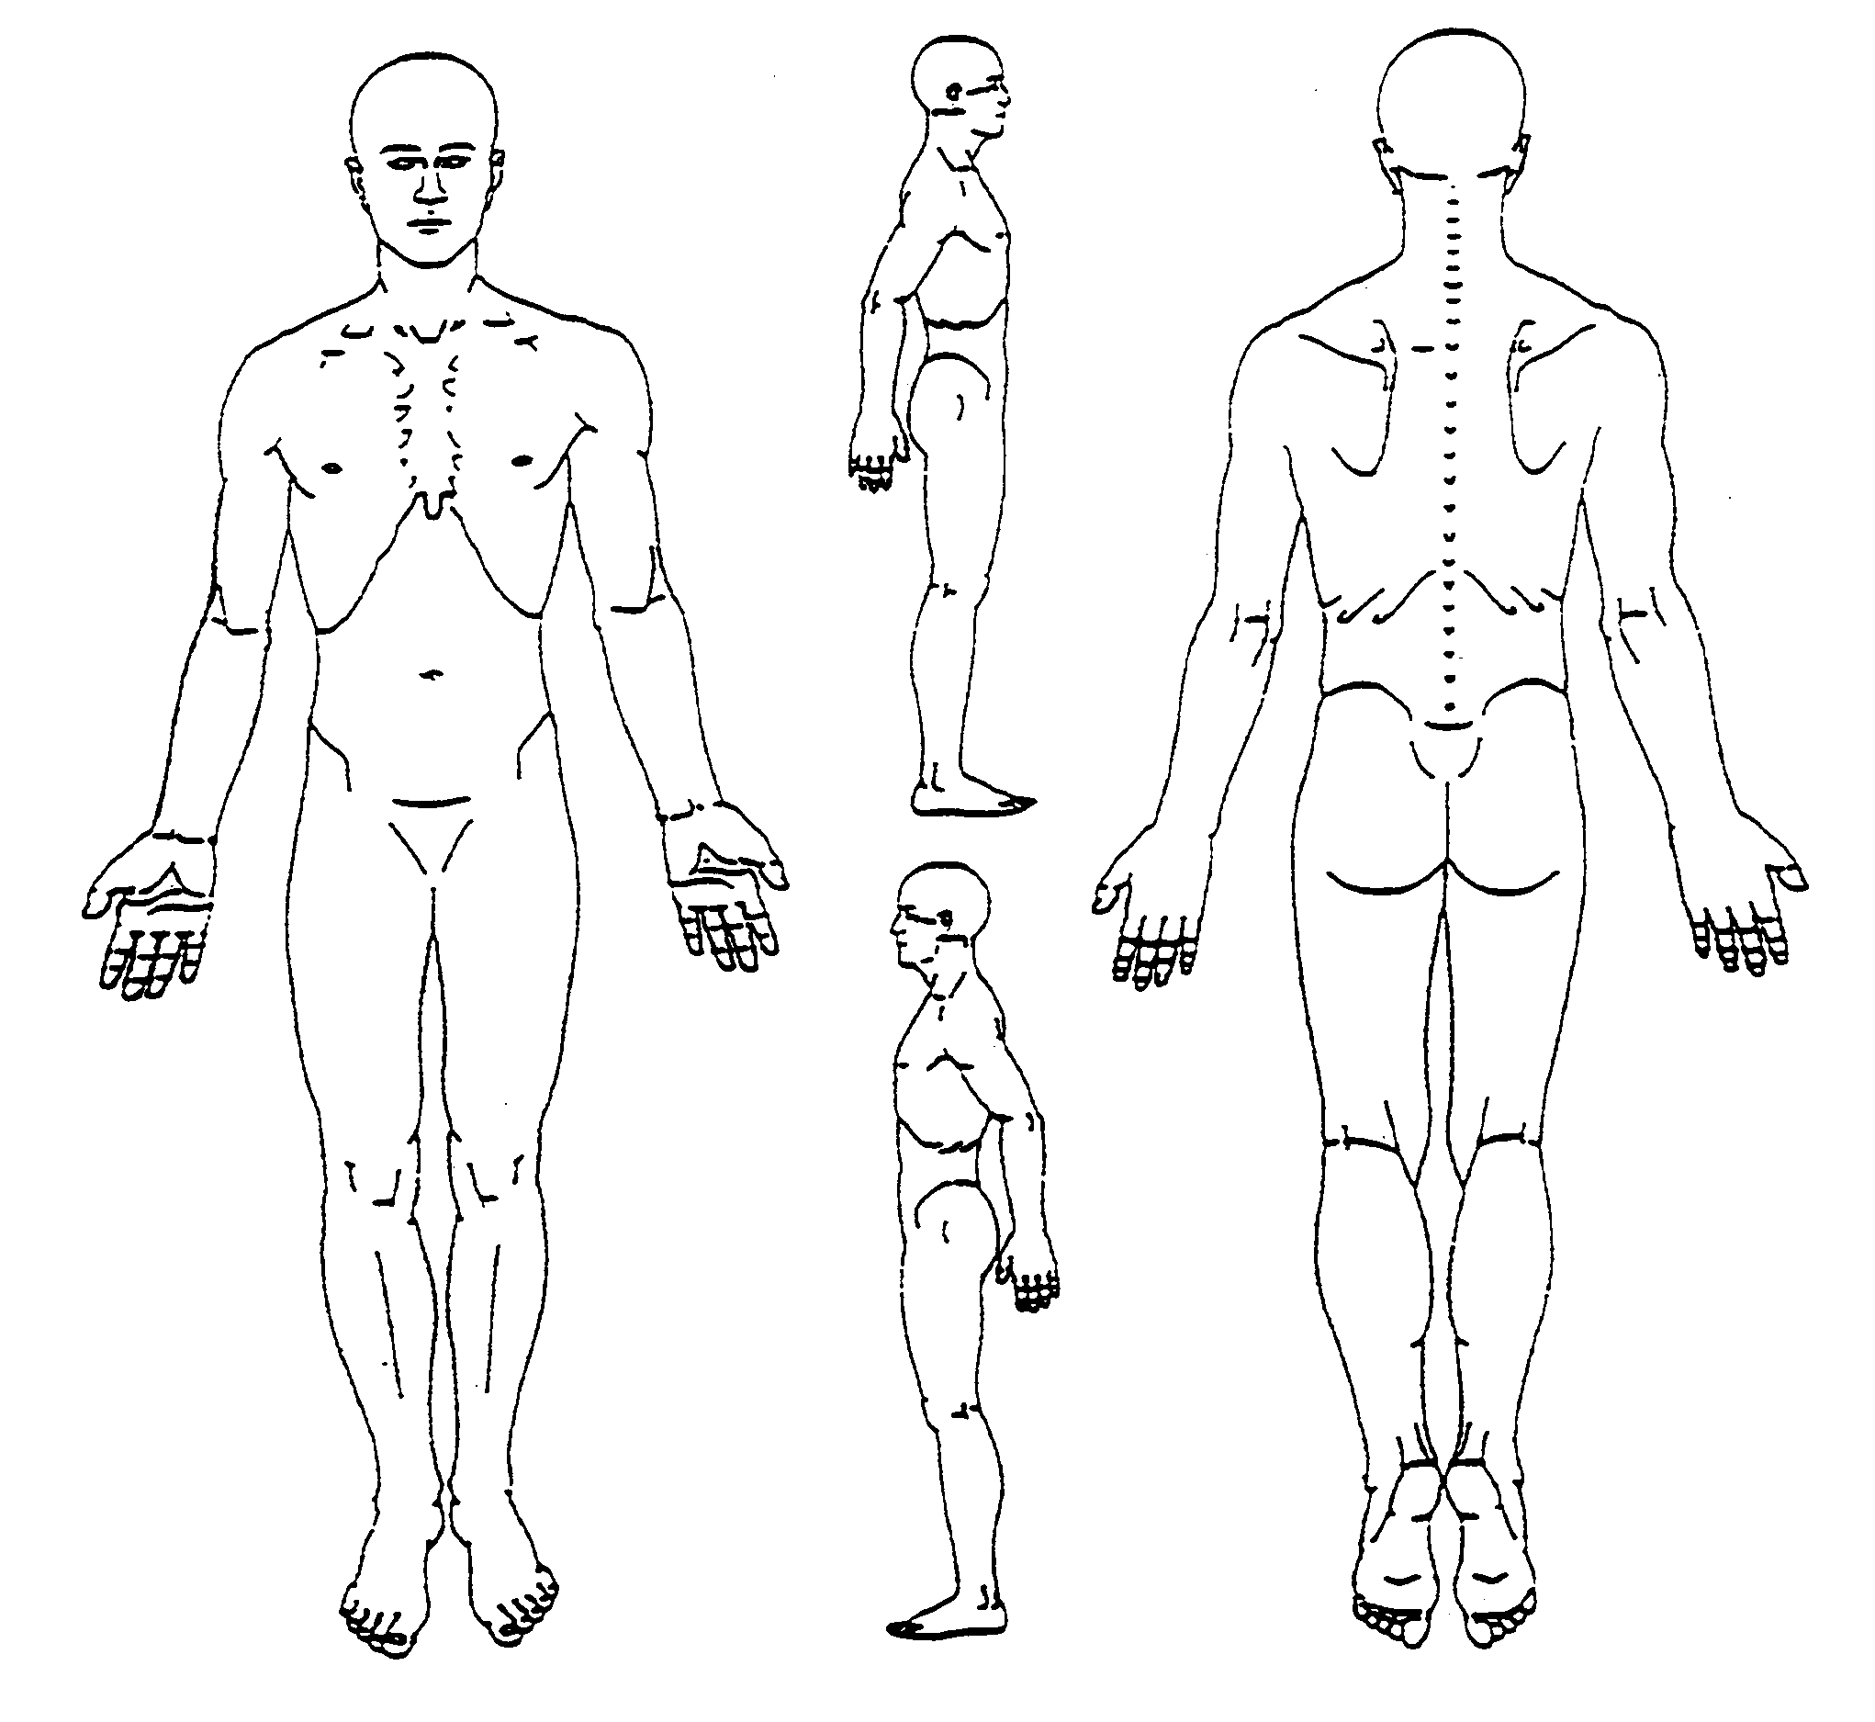

Using the pain scale below, circle the pain level you experience when this problem is at its very worst:

.
0 = No Pain. No Discomfort
1 = Minimal Discomfort. Minor stiffness or tightness.
2 = Discomfort. Stiff, tight, sore. Muscle fatigue.
3 = Minimal Pain. More than just sore. Uncomfortable.
4 = Mild Pain. Noticeable pain but tolerable.
5 = Moderate Pain. Aggravating. Still allows movement.
6 = Strong Pain. Quite aggravating. Movement slightly limited.
7 = Very Strong Pain. Very aggravating. Movement definitely limited.
8 = Very, Very Strong Pain. Extremely aggravating. Movement very limited.
9 = Severe Pain. Brings tears. Almost impossible to move.
10 = Excruciating Pain. Agony. Unbearable. Cannot move. ER.

Do you suffer from any other health conditions, regardless of whether you think they’re related to your spine: __________________________________________________________________________________________________
__________________________________________________________________________________________________
__________________________________________________________________________________________________

Do you have any radiating pain? ___________ Numbness or tingling? ________________

How long have you been suffering with this problem, has it been more than a month or two? ____________________

When was the first time you EVER recall having a problem in this area? _______________________________________

How often are you suffering with this problem?
Constant (75 – 100% of the time) _________________Frequent (50 – 75% of the time)_________________________

Occasional (25 – 50% of the time) ________________ Intermittent (0 – 25% of the time) _______________________

Every trauma you’ve ever had gets recorded in the spine. Please give a description of any injuries or accidents over the course of your life (falls, sports injuries, car accidents), whether or not you think they are related to your spine:

_____________________________________________________________________________________________________
__________________________________________________________________________________________________________________________________________________________________________________________________________

Have you been under previous chiropractic care? _________________________________________________________

List any MD’s or other physicians you’ve already seen for your current problem: __________________________________________________________________________________________________
What postures, positions and repetitive motions do you do most of the day? __________________________________
__________________________________________________________________________________________________

What tests have you already had for this problem? X-rays MRI C.T. Scan EMG/NCV None Other __________________________________________________________________________________________________

What have you already tried for this problem? Anti-inflammatory Pain Meds Muscle Relaxers
Injections Physical Therapy Chiropractic Massage Exercise Other __________________________________

What makes your problem worse? Sitting Standing Changing Position Walking Bending Lifting Twisting
Reaching Driving Sleeping Sneeze/Cough Computer Work Telephone Going From Sit to Stand Other_________________________________________________________________________________________

What activity has this problem prevented you from doing that you would really like to be able to do again? __________________________________________________________________________________________________

What area of your life has this the most? Family Relationships Work Exercise Recreation

__________________________________________________________________________________________________

On a scale of 1 to 10, with 10 being the highest, what is your level of commitment to get rid of this problem: __________

Please list any concerns you may have about getting this problem corrected such as time or transportation:

____________________________________________________________________________________________________

On a scale of 1 to 10 with 1=Poor and 10=Excellent, please rate how well you think you are doing in the following categories:

Exercise________ Sleep ________ Diet _________ Stress Level _______ Water Intake ________ Energy Level__________

Do you take: Omega 3 (Fish Oil)? Yes No Vitamin D3? Yes No Probiotics? Yes No

Who is your Family Physician or Primary Doctor that monitors you? __________________________________________________

PAST MEDICAL HISTORY

Please list any significant conditions that you’ve been diagnosed with or been treated for over the course of your life: _________
_________________________________________________________________________________________________

Please list any surgeries you have had over the course of your life: ___________________________________________________

MEDICATIONS

List any medications you are taking: _____________________________________________________________________________

FAMILY HISTORY

Mother:[Symbol]Living [Symbol]Deceased List any medical problems: ______________________________________________________________

Father:[Symbol]Living [Symbol]Deceased List any medical problems: _______________________________________________________________

List any problems common in your family:[Symbol]Cancer [Symbol]Diabetes [Symbol]Heart disease [Symbol]High blood pressure [Symbol]Stroke [Symbol]Arthritis
[Symbol]Scoliosis [Symbol]Thyroid disease [Symbol]Osteoporosis[Symbol] Other _______________________________________________________

SOCIAL HISTORY

Do you have any children?[Symbol]Yes [Symbol]No If yes, how many? _____________________________________________________________

Do you drink alcohol?[Symbol]Yes [Symbol]No If yes, how much & how often? _______________________________________________________

Smoking Status (Circle one): Every Day Smoker / Occasional Smoker / Former Smoker / Never Smoked

